Phase 6 – Planning, Memory, Retention Rules

Routes And Flow
The system follows this flow:
User Query
-> Streamlit UI
-> LangGraph Orchestration
-> Planner Agent
-> Risk & Compliance Agent
-> MCP Tool Calls
-> Risk & Compliance Check
-> Response Generation Agent
-> Final Response
The Planner decides the route. The Risk Agent checks if the request is safe, needs approval, or must be blocked. MCP tools only retrieve, calculate, update, or escalate. The final response is role-aware and hides internal tool details.

Results Before Phase 6:

Ex 1 : No Proper routing with Just tools. No proper explanations.
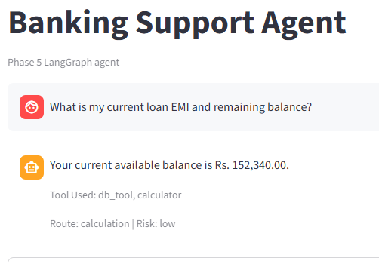
Ex2: No understanding of the intent of Query. With word balance it automatically routes to DB and only fetches data

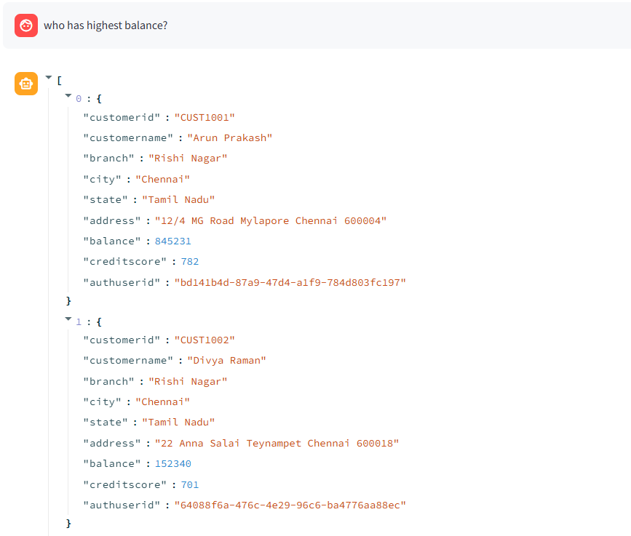
Ex3: IS rule based and couldn’t map this to DB tool
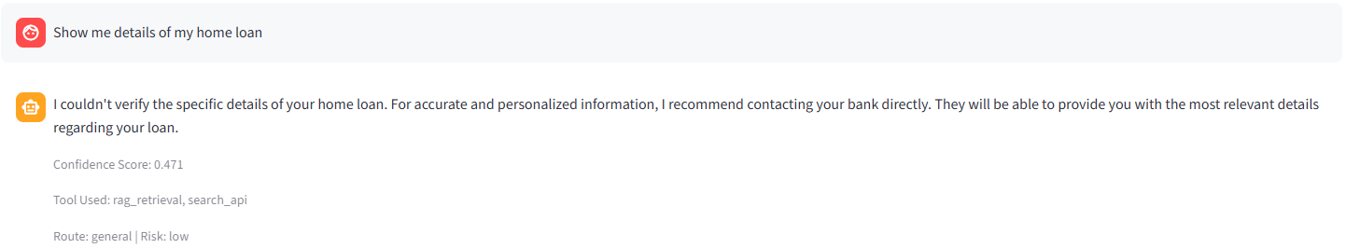
Ex4: Branch manager privileges are not added.
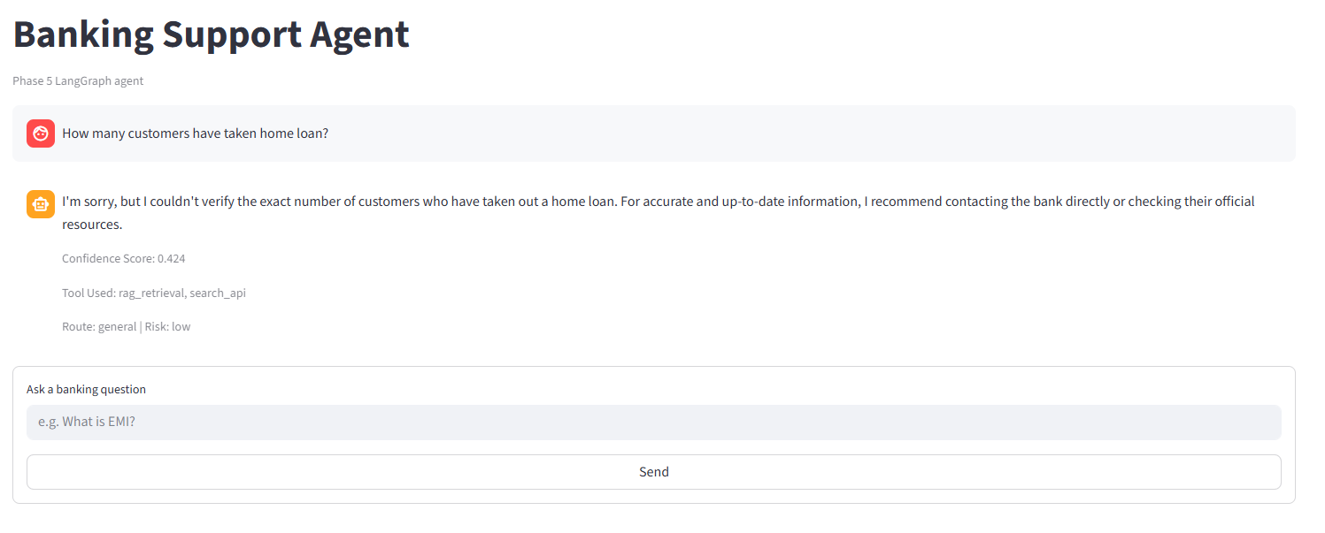

Ex 5:Metadata is shown: no user facing response
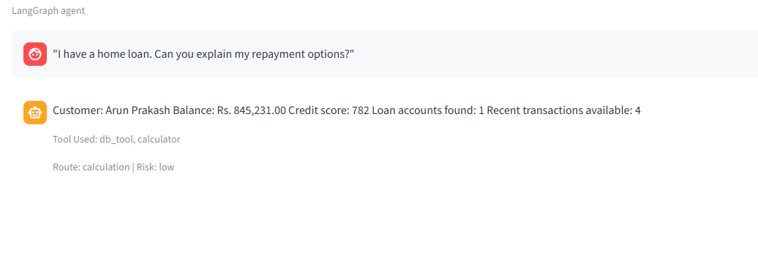

Main Routes

General Banking Query
Used for FAQs, product information, policy questions, and comparison queries.
Flow:
Planner -> RAG Tool -> if confidence low, Search API -> Response Agent
Sample queries:
What is EMI?
Compare savings account and current account.
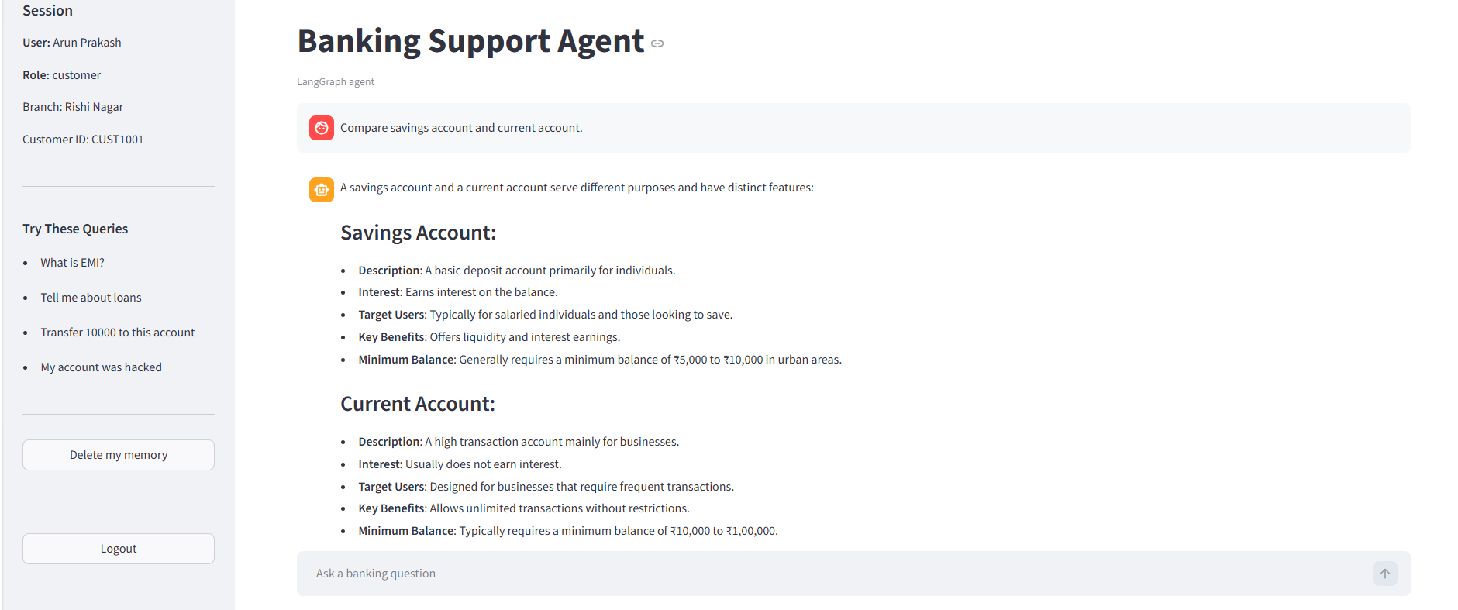
What documents are needed for KYC?
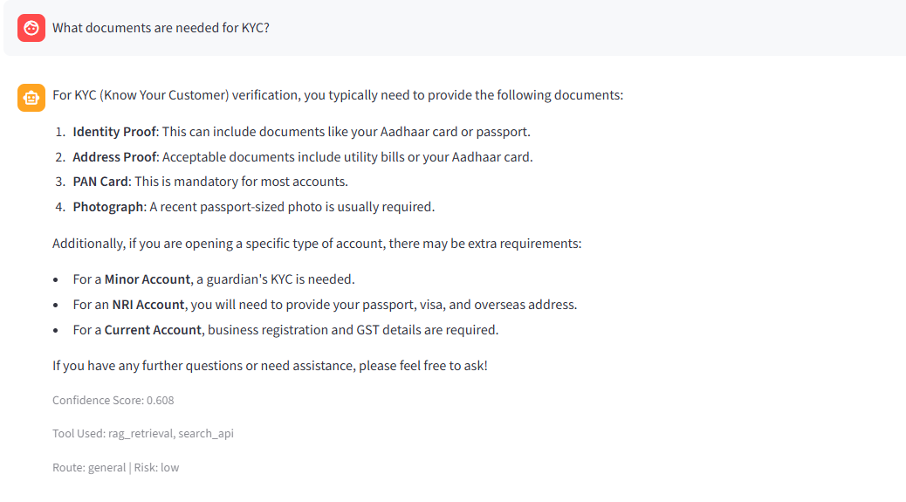
What are the features of a fixed deposit?

Personalized Query
Used when the answer needs customer, account, branch, loan, or transaction context.
Flow:
Planner -> Risk Check -> DB Tool -> optional RAG/Search for policy guidance -> Response Agent
Sample customer queries:
What is my balance?
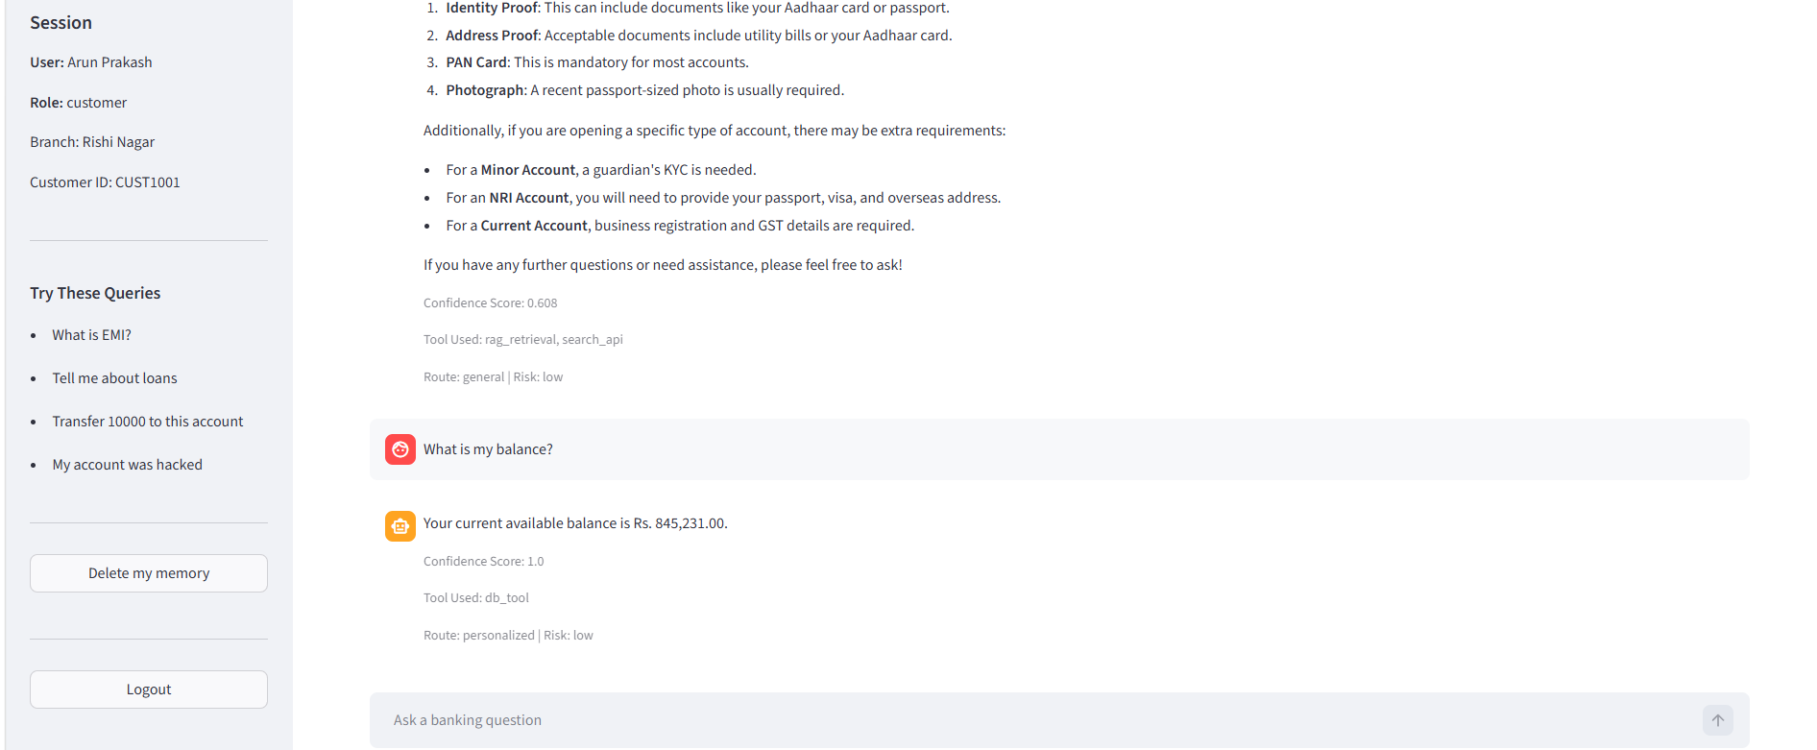

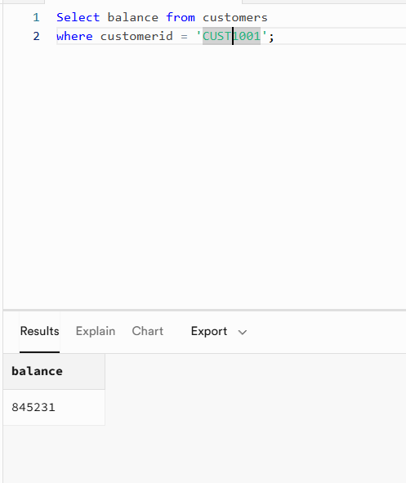
Show my latest transactions.
I have a home loan. Can you explain my repayment options?
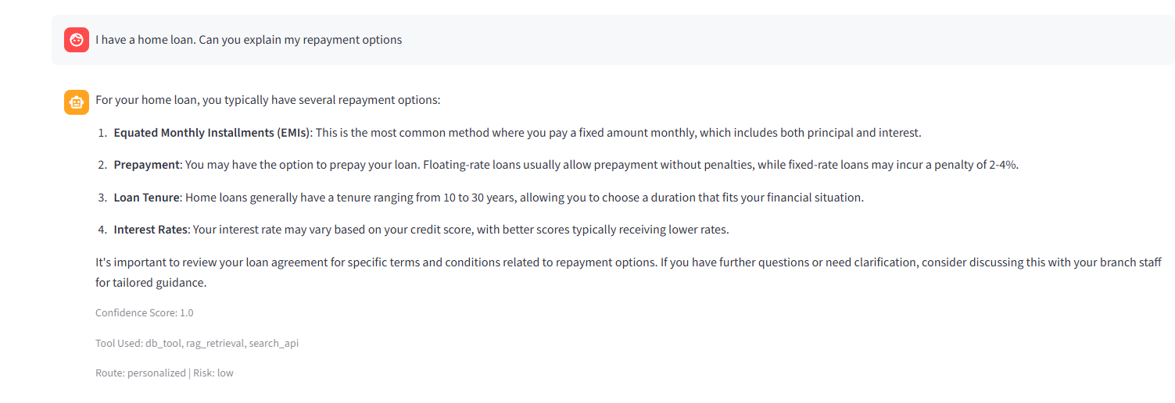
What if I pay extra Rs. 10,000 every month?

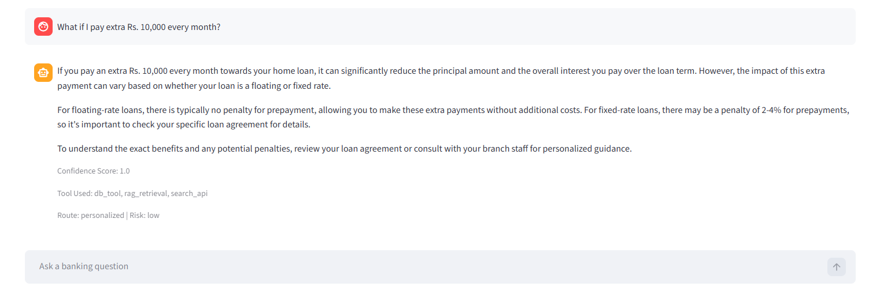
Sample manager/risk queries:
Who all have opted for loan in my branch?
Show customer C001 details.

Calculation Query
Used for EMI, interest, repayment, maturity, eligibility, or balance calculations.
Flow:
Planner -> fetch required DB/RAG context -> Calculator Tool -> Response Agent
Sample queries:
Calculate EMI for 500000 at 8.5% for 5 years.
What is the interest on Rs. 100000 at 7% for 2 years?
What if I pay extra Rs. 10000 every month?

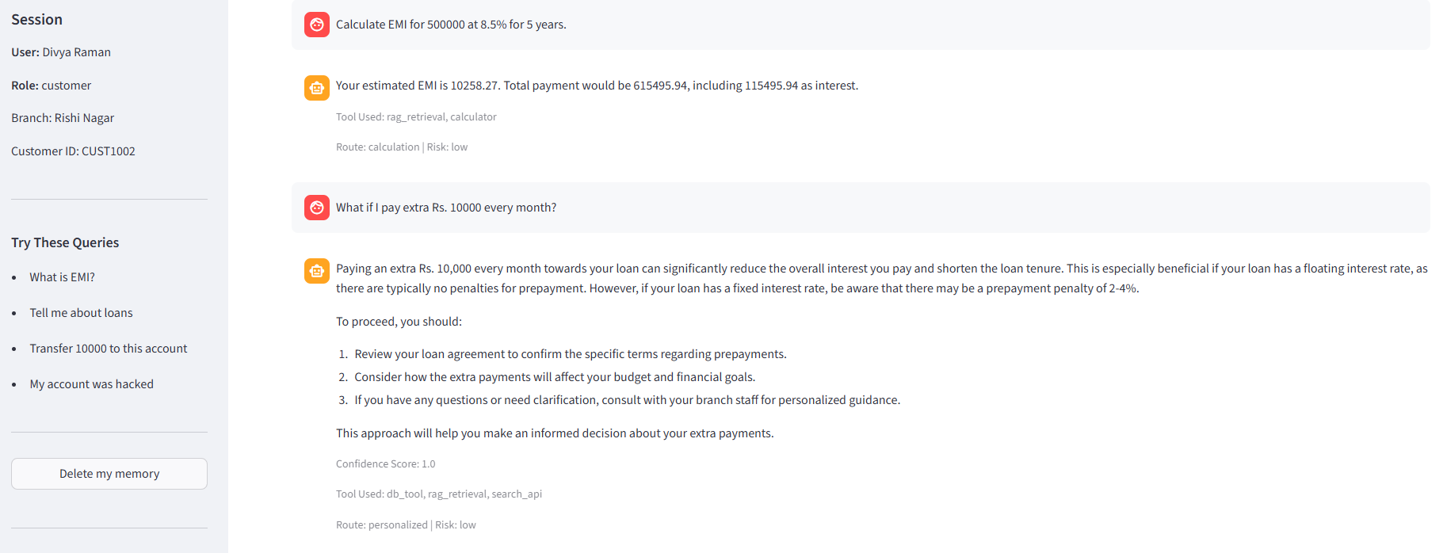

Escalation / Approval Query:
Used for ambiguous, sensitive, high-risk, or maintenance requests.

Flow:
Planner -> Risk Agent -> Escalation Tool -> Human Review

Sample medium-risk queries:

Customer View:

Open an FD for me/ Close my account.
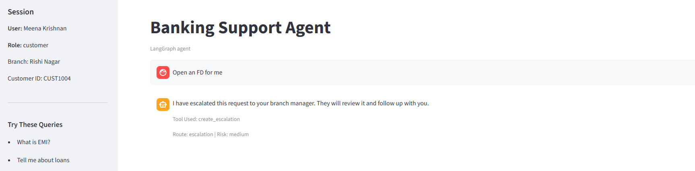
Update my address.
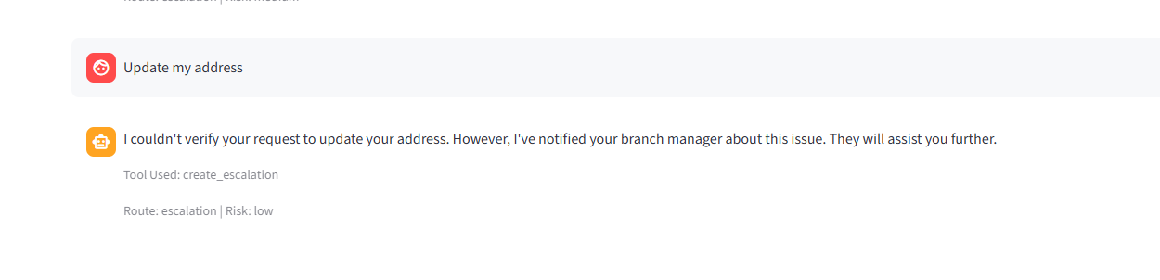

Branch Manager View:

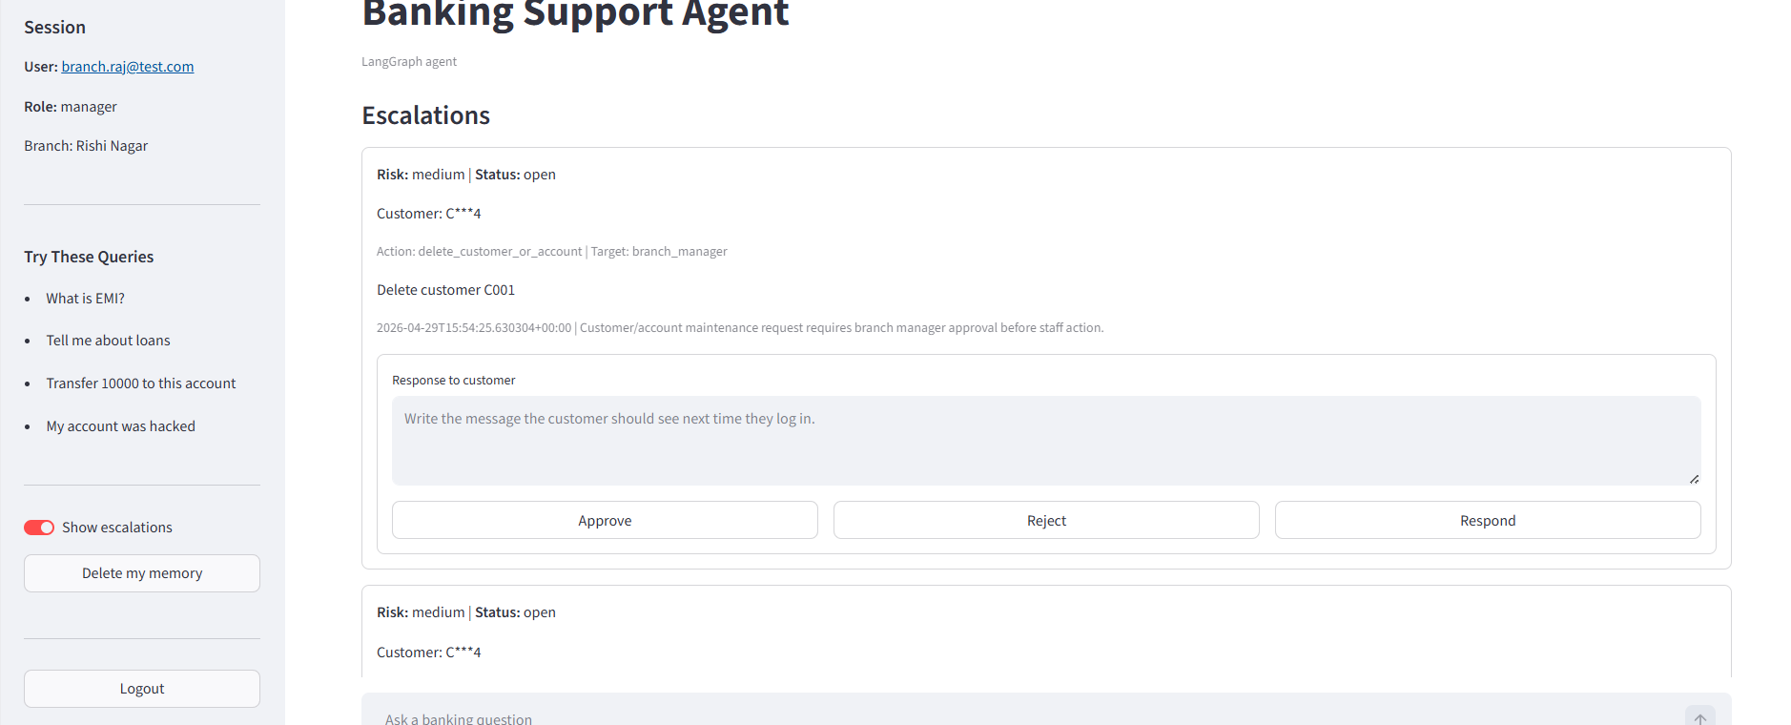

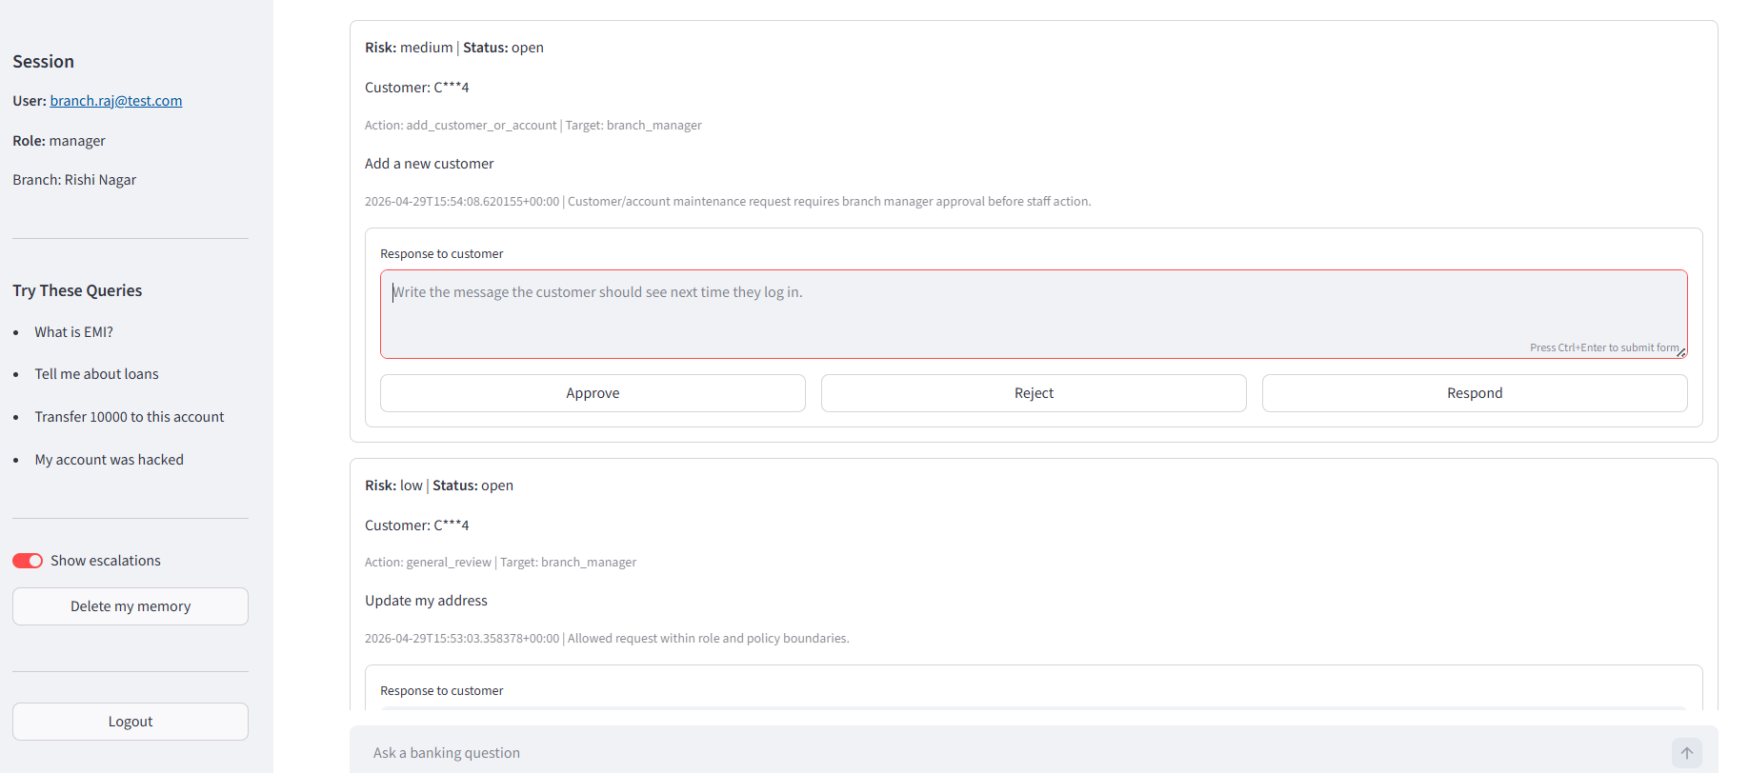

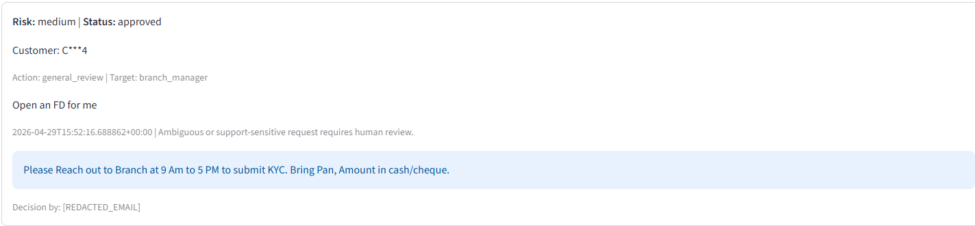

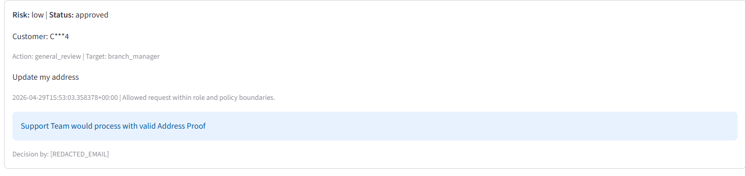
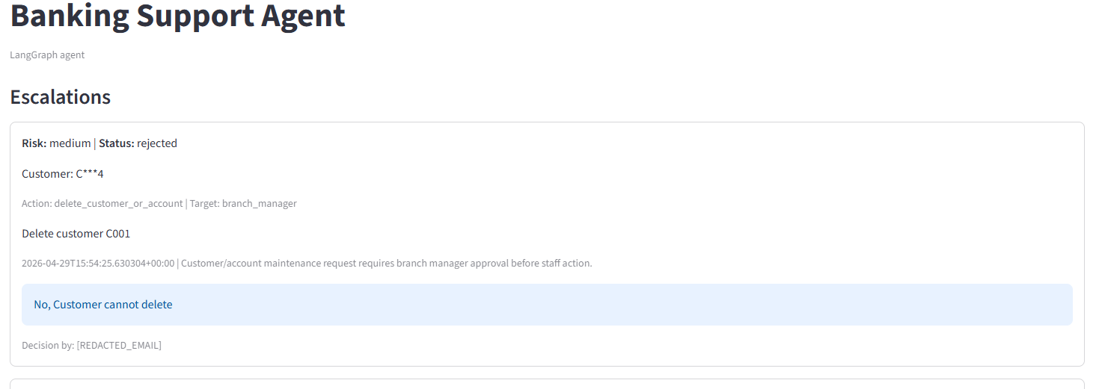

Customer re-login View:

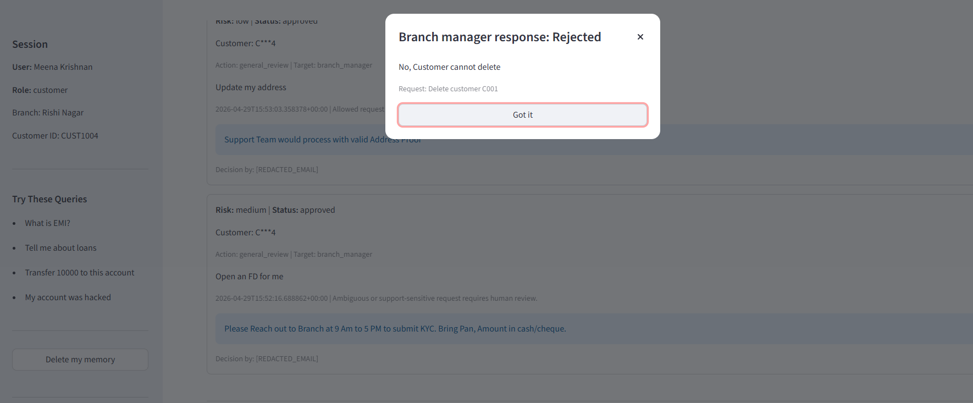
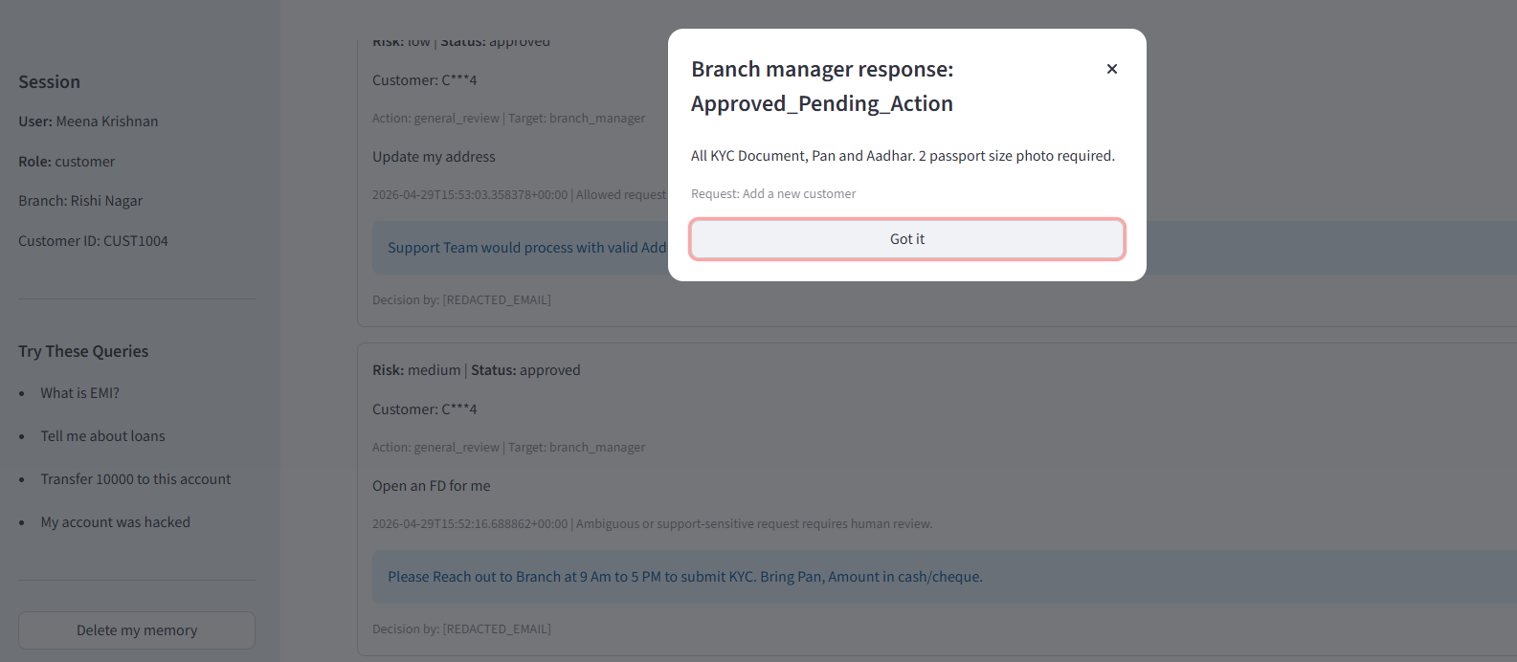
Change my phone number.
Add a new customer.
Delete customer C001.
I want to dispute a failed transaction.

Sample high-risk queries:

Customer View:
Transfer Rs. 10000 to this account.
My account was hacked.
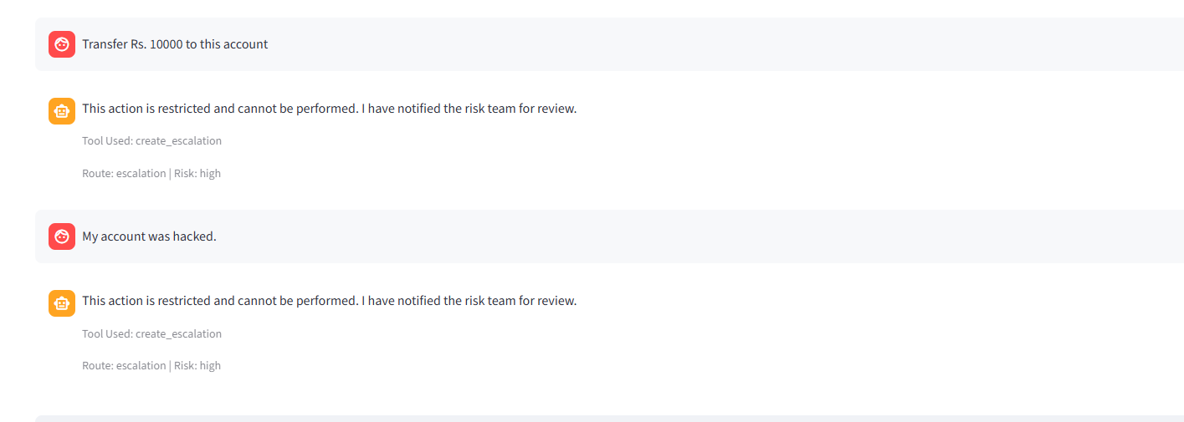

Risk and Compliance team View:
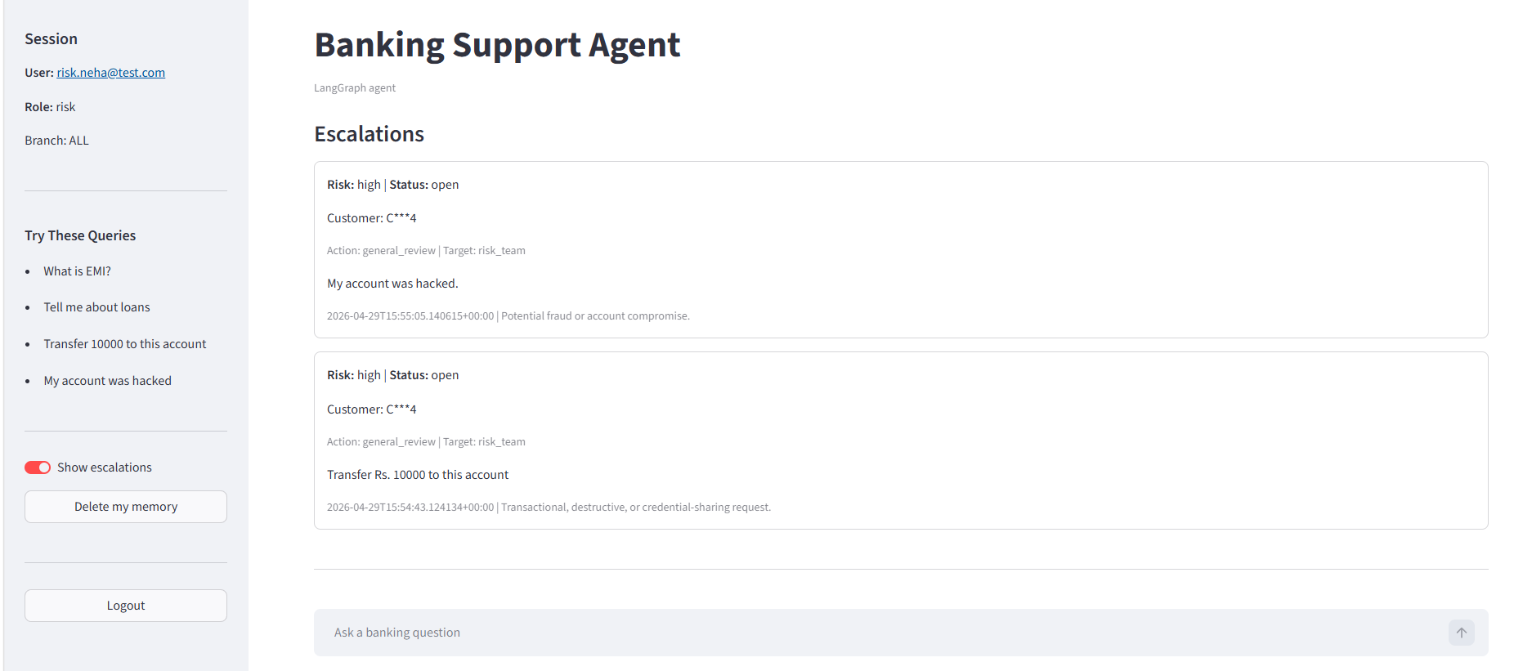
Someone asked for my OTP.
Can you show my PIN?
Draft a legal notice to sue the bank.

Role-Based Flow

Customer
- Can ask general banking questions.
- Can ask about own account/loan/transactions.
- Cannot access other customers’ data.
- Medium-risk requests go to branch manager.
- High-risk requests are blocked/escalated.

Branch Manager
- Can ask policy and branch-related questions.
- Can view branch escalations.
- Can approve, reject, or respond.
- Approved add/delete requests move to Admin.
- Approved profile/contact updates move to Support.

Admin
- Handles approved customer/account add/delete actions.
- Executes Supabase add/delete after verifying documents.
- Sees success/failure result.

Support
- Handles approved name, phone, address, city, state, and pincode updates.
- Executes Supabase contact updates after verification.

Risk
- Views high-risk escalations.
- Can ask authorized customer investigation questions.
- Handles fraud, hacked account, OTP, phishing, and restricted-action cases.

Short-Term Memory
- Stored in Streamlit session state:
st.session_state.chat_history
- Used during the active chat session.
- Helps the planner understand follow-up questions.
Example:
Q1: I have a home loan. Can you explain my repayment options?
Q2: What if I pay extra Rs. 10,000 every month?
The second question uses short-term memory to understand that it still refers to the home loan.

Long-Term Memory
- Managed by:
app/memory/store.py
- Stored locally in:
data/conversation_memory.jsonl
- Also attempts to store in Supabase table:
conversation_memory
if Supabase is configured.

Retention
- Memory is deleted after 60 days of inactivity.
- User can delete memory manually using Delete my memory in the Streamlit sidebar.

PII Handling
- User ID is hashed before storage.
- Query and response are redacted before storage.
- Personalized DB responses are stored as:
[REDACTED_PERSONALIZED_RESPONSE]
- Raw account/customer data is not stored in memor

Safety Rules
- No money movement.
- No loan approvals.
- No legal advice.
- No raw PII in logs.
- Personalized DB data is not sent to the LLM.
- Logs store redacted or masked values only.

